觀課


NTU Classroom Observation Service

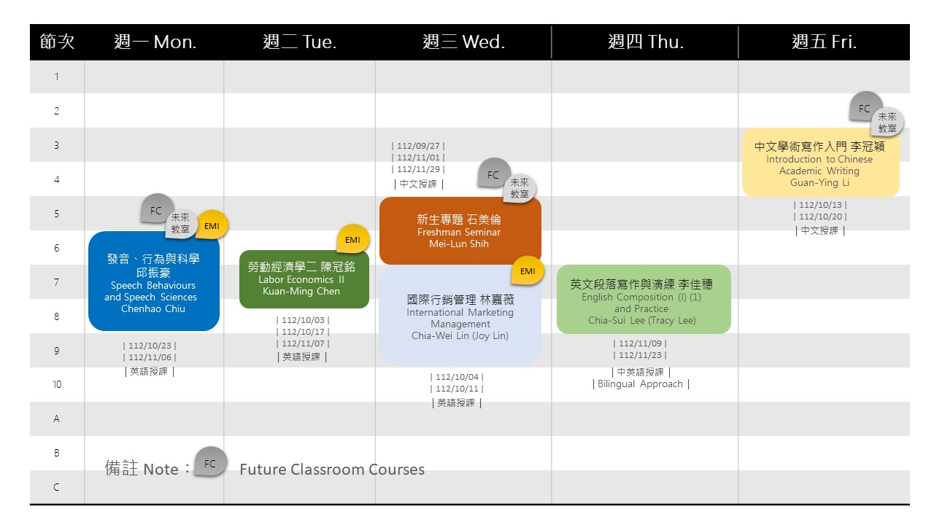
Learn more from our website: https://reurl.cc/60RoYb 
Application Form
Name |
Department |
Email |
Which course do you want to sign in for observation?
Course I | Course II |
What date do you want to choose?
Attended Date for Course I | mm/dd Attended Date for Course II | mm/dd
--------------------------------------------------------------------------------------------------
Matching will be conducted by Iris Chang from the Center for Teaching and Learning Development. Please email the application form to Iris Chang (ifan@ntu.edu.tw). After successful matching, notifications will be sent to both the applying teachers and class teachers.

